Debugging Log

# Defect Information

**Defect ID:** Bug 1 – Incorrect calculation of fines

**Priority:** Major

**Status:** ASSIGNED

**Last updated:** 2020-10-16

**Assigned to:** Sam Johnson

## Reported Issue

When a book becomes overdue by one day, no fine is imposed.

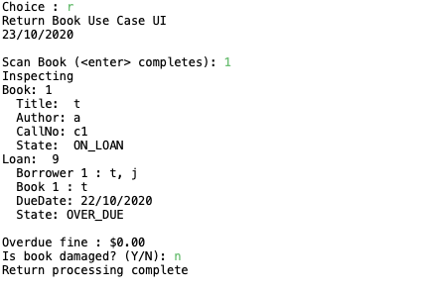

# Replication

## Setup

* Patron created with data as per Test Data
* Patron state is CAN_BORROW
* Patron fines are below fine limit
* Book created with data as per Test Data
* Book state is AVAILABLE
* Recorded Patron ID and Book ID

## Tear down

* Remove library.obj file

## Steps

| **#** | **Test Action** | **Expected Results** |
| --- | --- | --- |
| 1 | Enter ‘L’ at the main menu, and press Enter | Borrow Book use case UI starts. Prompt to swipe Patron card. |
| 2 | Enter Patron ID, press Enter | Prompted to scan book. |
| 3 | Enter Book ID, press Enter | Prompted to scan another book. |
| 4 | Press Enter | System displays Final Borrowing List. Prompts to Commit Loans. |
| 5 | Enter ‘Y’, press Enter | Completed Borrowing List displayed, prompted to enter any key to exit. |
| 6 | Press Enter | Main menu displayed |
| 7 | Enter ‘T’, press Enter | Prompted to enter the number of days |
| 8 | Enter Number of Days (3), press Enter | Displays new date followed by main menu |
| 9 | Enter ‘R’, press Enter | Return Book use case UI starts. Prompt to scan book. |
| 10 | Enter Book ID, press Enter | Displays inspecting book, book details, and loan details. Prompted to confirm if book is damaged.  Bug evident: Loan State is OVER_DUE Overdue Files is $0.00 |
| 11 | Enter ‘N’, press Enter | Main menu is displayed |

## Test Data

| **Description** | | **Data** |
| --- | --- | --- |
| Patron 1 | Last name | Mustermann |
| First name | Max |
| Email | max.mustermann@example.com |
| Phone | 123456789 |
| Book 1 | Author | Herman Melville |
|  | Title | Moby Dick |
|  | Call Number | c123 |
| Number of Days | | 3 |

## Replication Comments

Confirmed issue occurs when loan is overdue by a single day. Returning two days late incurs a fine (fine amount is incorrect, already raised as Bug 2). Returning on time functions as expected. Issue is unchanged by the amount of books borrowed.

# Simplification/Tracing

|  |  |
| --- | --- |
| **Hypothesis #1** | |
| Defect occurs within ReturnBookControl.bookScanned() processing. | |
| **Expected State** | **Actual State** |
| bookId and patronId remain the same | IDs remained the same |
| Loan State remains OVER_DUE | State remained OVER_DUE |
| Fines Payable remains 0.0 | Fines Payable remained the same |
| **Conclusion** | |
| Hypothesis confirmed. Patron fines after bookScanned() should have increased and have not. | |

**Screenshots/Comments:**

|  |  |
| --- | --- |
| **Hypothesis #2** | |
| Defect occurs within the call to library.calculateOverdueFine(currentLoan) | |
| **Expected State** | **Actual State** |
| Return value equals 0.0 | Returns 0.0 |
| **Conclusion** | |
| Hypothesis confirmed. Overdue fine calculation returns 0.0 | |

**Screenshots/Comments:**

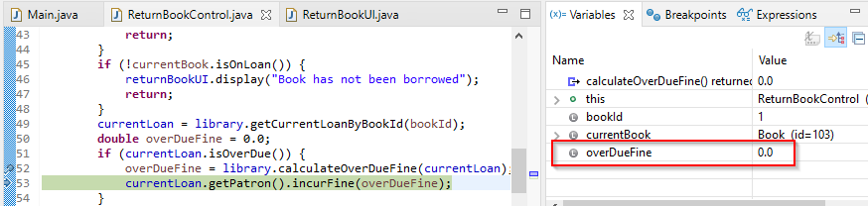

Can write an automated test for Library.calculateOverdueFine().

|  |  |
| --- | --- |
| **Hypothesis #Click or tap here to enter number.** | |
|  | |
| **Expected State** | **Actual State** |
|  |  |
|  |  |
| **Conclusion** | |
|  | |

**Screenshots/Comments:**

# Resolution

<Describe defect cause, proposed/implemented fix, test results of remediated code>

# Regression Testing

<Describe regression testing undertaken and anomalous results>